## Part B - DC/Stepper Motor Hat ([adafruit directions](https://learn.adafruit.com/adafruit-dc-and-stepper-motor-hat-for-raspberry-pi/assembly))

Parts: [GPIO Stacking Header](http://adafru.it/2223) for A+/B+/Pi 2

[Adafruit](http://adafru.it/2348) DC & Stepper Motor HAT for Raspberry Pi - Mini Kit

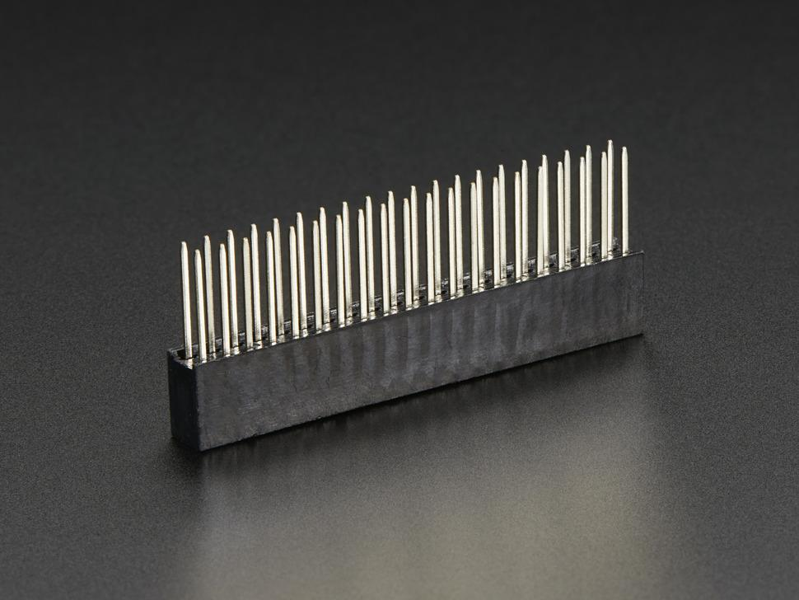 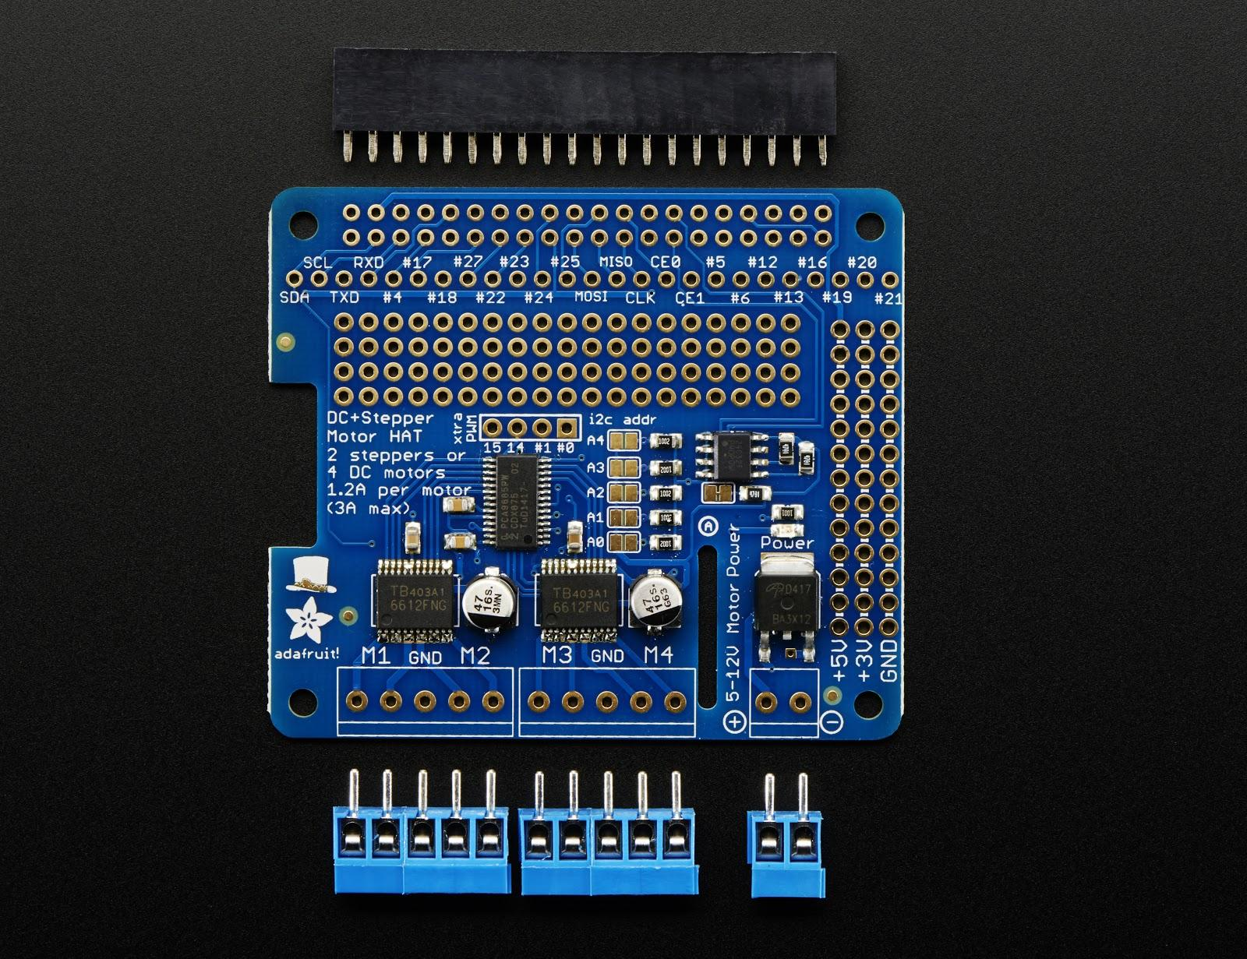

Instructions:

* 1. Make a 5 pin terminal block by sliding the included 2 pin and 3 pin terminal blocks into each other.



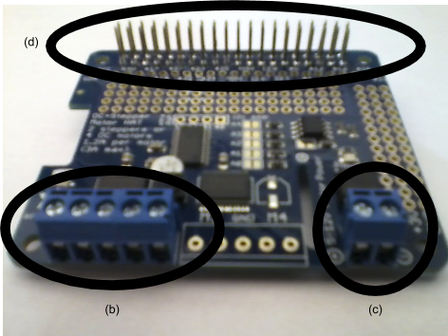

* 1. Slide this 5 pin block through the holes just under "M1 GND M2" on the board. Solder it on (we only use two motors and do not need connect anything at the "M3 GND M4" location)
  2. Slide a 2 pin terminal block into the corner for power. Solder it on.
  3. Slide in the GPIO Stacking Header onto the 2x20 grid of holes on the edge opposite opposite the terminal blocks. Solder it on.

## Part C - 16-channel PWM/Servo HAT ([adafruit directions](https://learn.adafruit.com/adafruit-16-channel-pwm-servo-hat-for-raspberry-pi/))

Parts: [GPIO Stacking Header](http://adafru.it/2223) for A+/B+/Pi 2

[Adafruit](http://adafru.it/2327) 16-Channel PWM / Servo HAT for Raspberry Pi - Mini Kit

 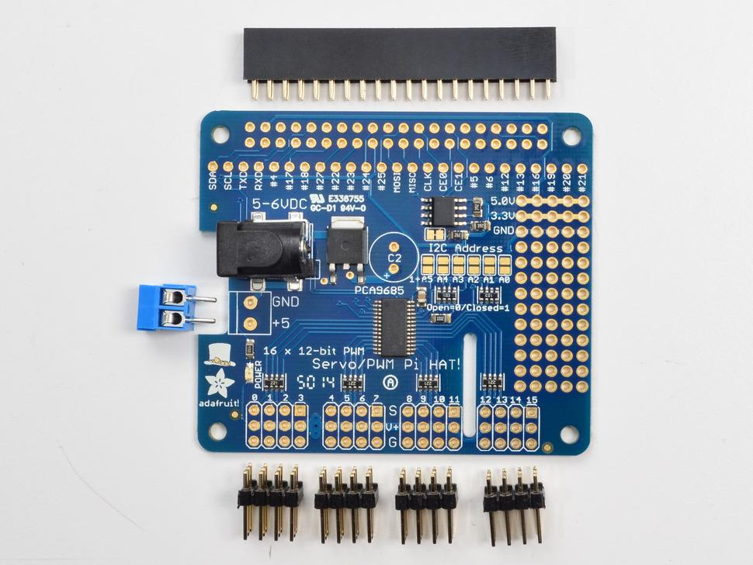



Instructions

* 1. Solder the GPIO Stacking Header at the top of the board, where the 2x20 grid of holes is located.
  2. Solder the 2 pin terminal block next to the power cable jack
  3. Solder the four 3x4 headers onto the edge of the HAT, below the words "Servo/PWM Pi HAT!"

## Part D - RPi 2 LSD board

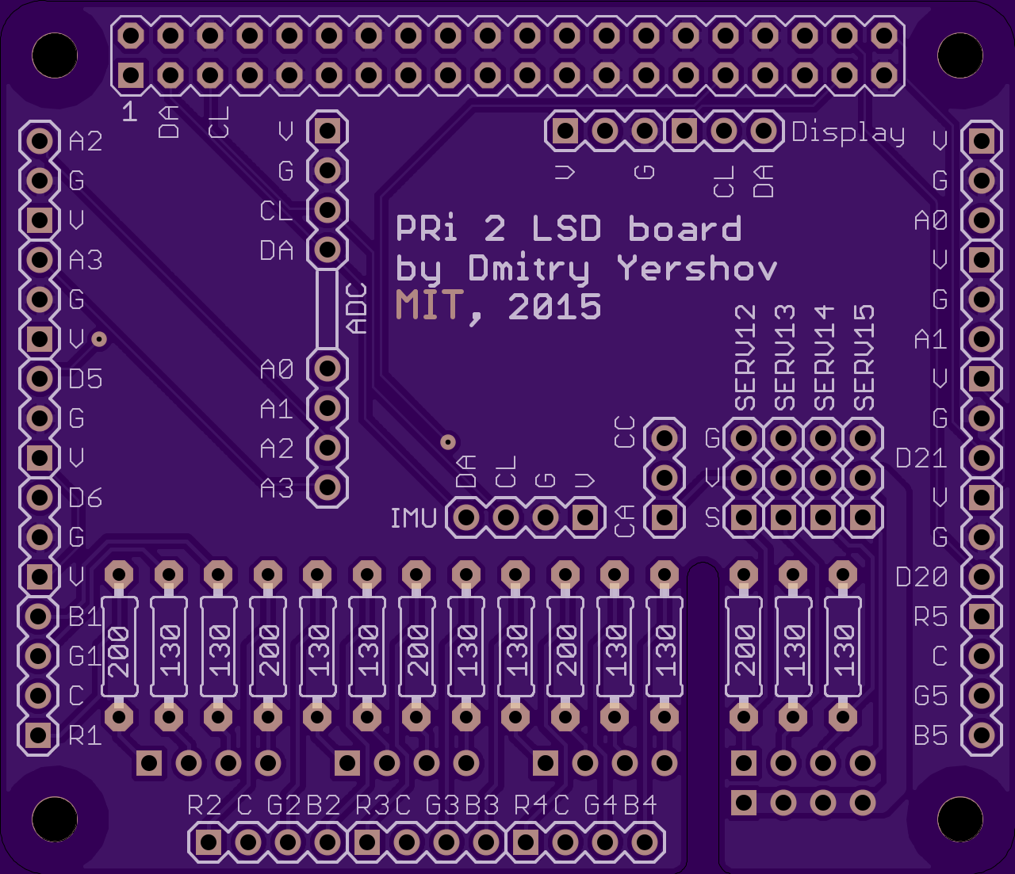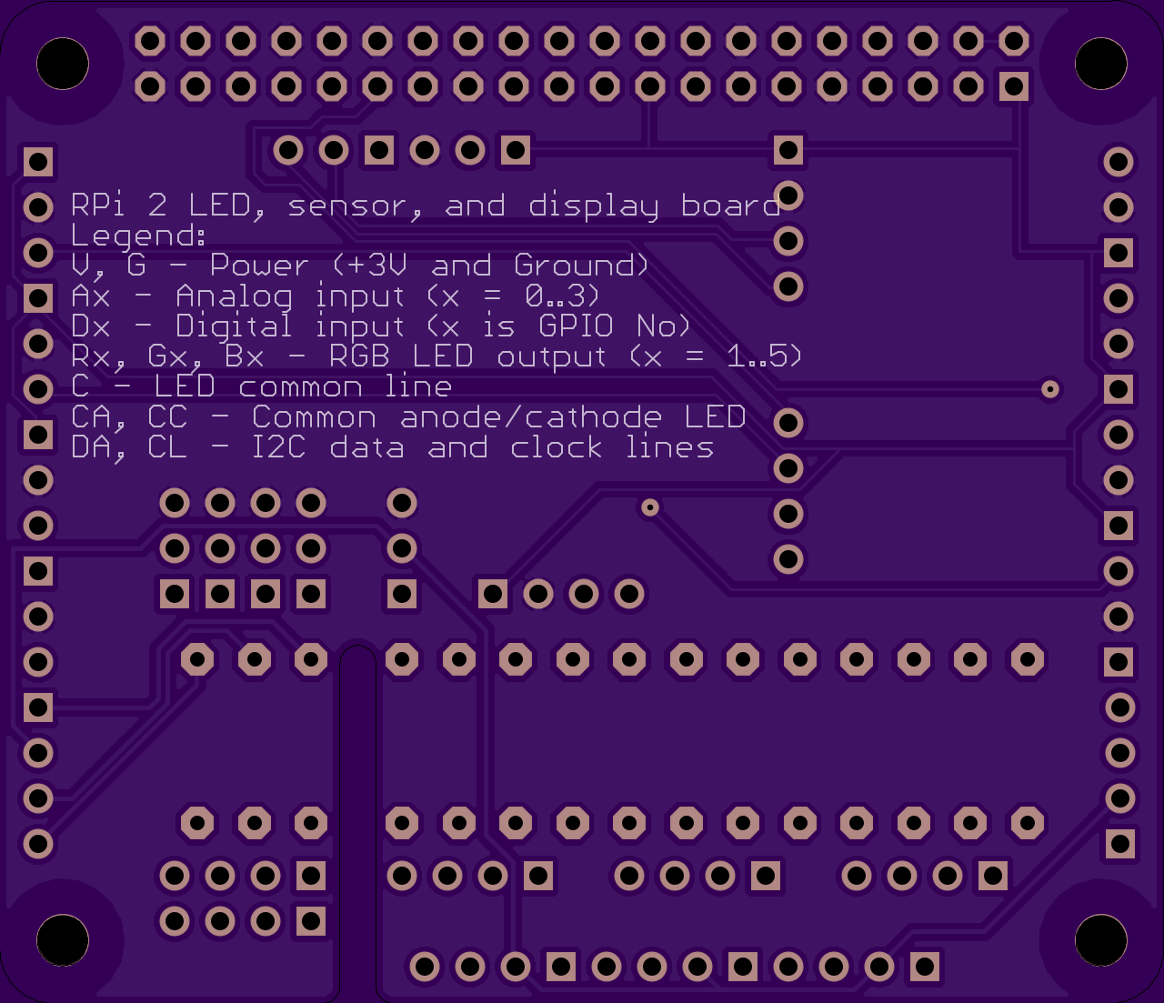

Parts list:

* 1 x 40 pin female header
* 5 x 4 pin female header
* 2 x 16 pin male header
* 1 x 12 pin male header
* 1 x 3 pin male header
* 1 x 2 pin female shunt jumper
* 5 x 200 Ohm resistors
* 10 x 130 Ohm resistors
* 2 x 4 pin male header for ADC daughterboard
* 1 x 4 pin male header for IMU daughterboard
* 3 x 4 pin male header for servos
* 1 x 6 pin male header for display daughterboard

Instructions:

* 1. Solder all female headers to the bottom of the board. Alignment becomes easy if the female headers are plugged into the PWM heat, and the LSD board rests on top.
  2. Solder all resistors to the top of the board according to silkscreen markings.
  3. Solder all male headers to the top of the board. Male header positions are outlined on the silkscreen.

## Part E - ADC daughterboard

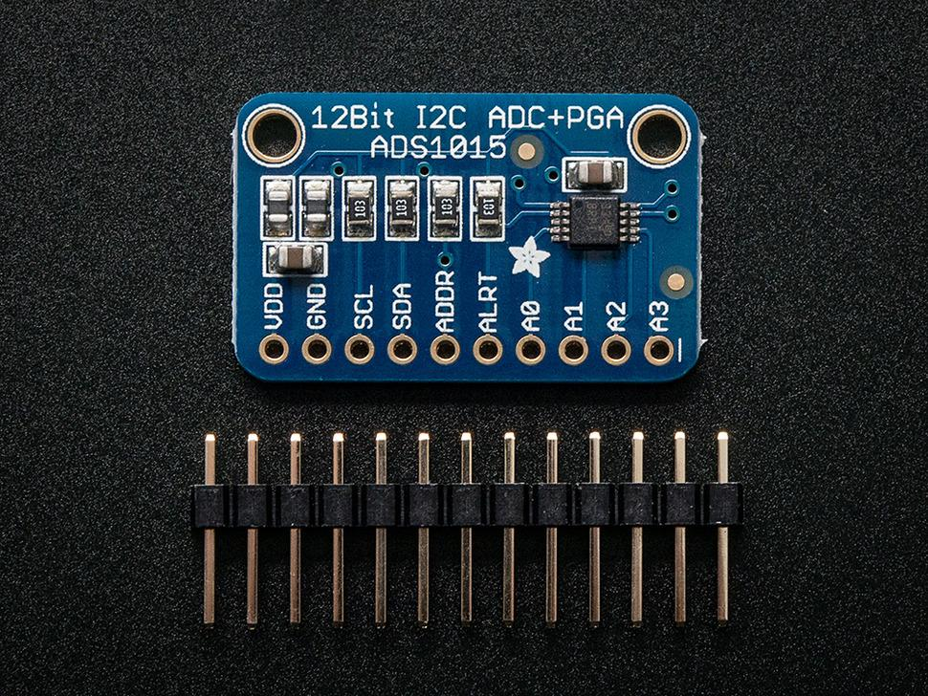

Parts list:

* 2 x 4 pin female header

Instructions:

* 1. Solder female headers to the top of the board, where all other components are. The first header is to be soldered on pins VDD, GND, SCL, SDA. The second header is to be soldered on pins A0, A1, A2, A3. Note that it is easy to align headers once they are mated to the corresponding pins on RPi 2 LSD board.

## Part F - IMU daughterboard

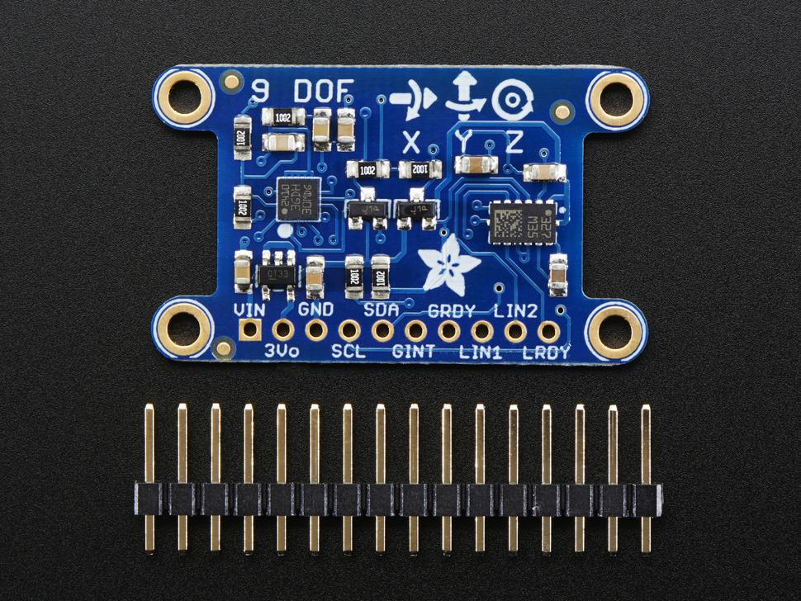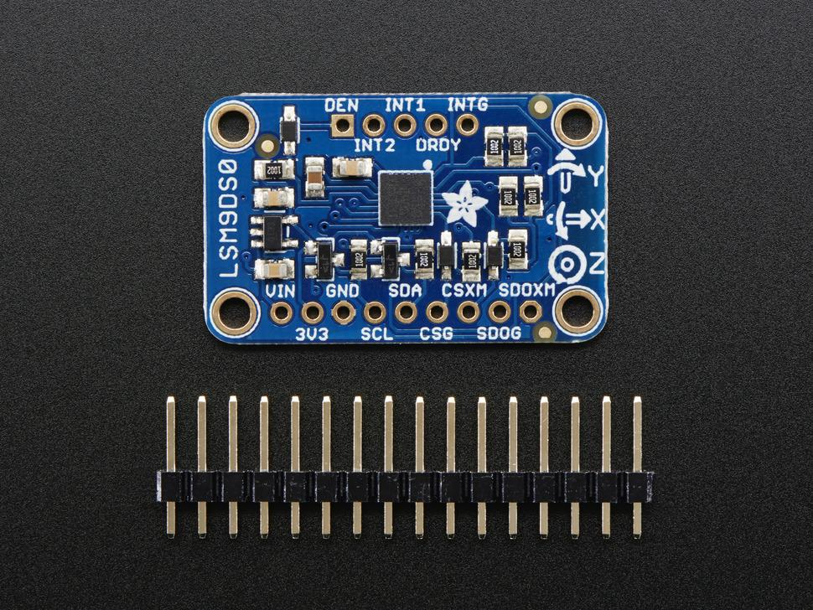

Parts list:

* 1 x 4 pin female header if mounting on top of LSD board
* 1 x 4 pin male header if mounting separately

Instructions:

* 1. Solder headers between 3Vo, GND, SCL, SDA. Female header must be soldered to the bottom of the board, and male headers must be soldered to the top of the board, where all other components are.
  2. Boards with L3GD20H + LSM303 and LSM9DS0 are electrically compatible; however, different drives must be used for either case.

## Part G - Display daughterboard

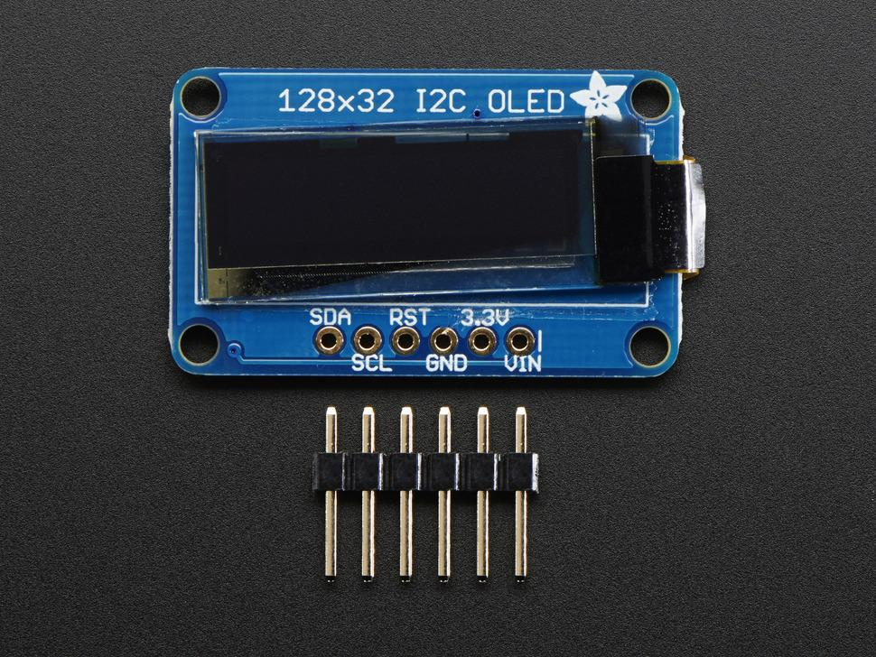

Parts list:

* 1 x 6 pin female header

Instructions:

* 1. Solder the header to the bottom of the board (on the opposite to the screen side).

## Part H - LED connection

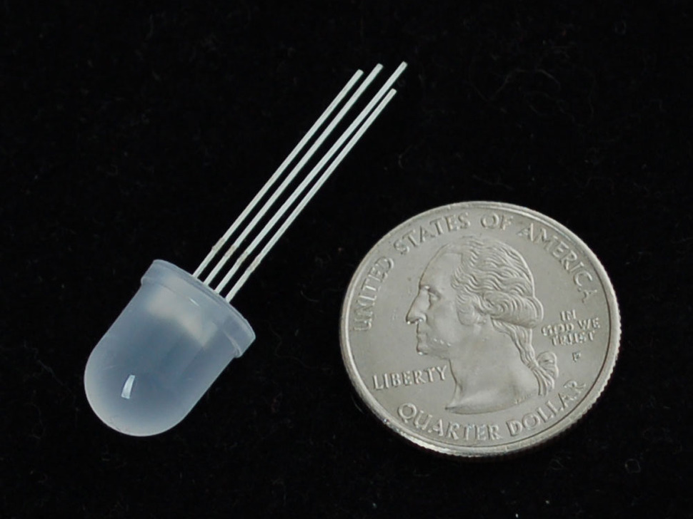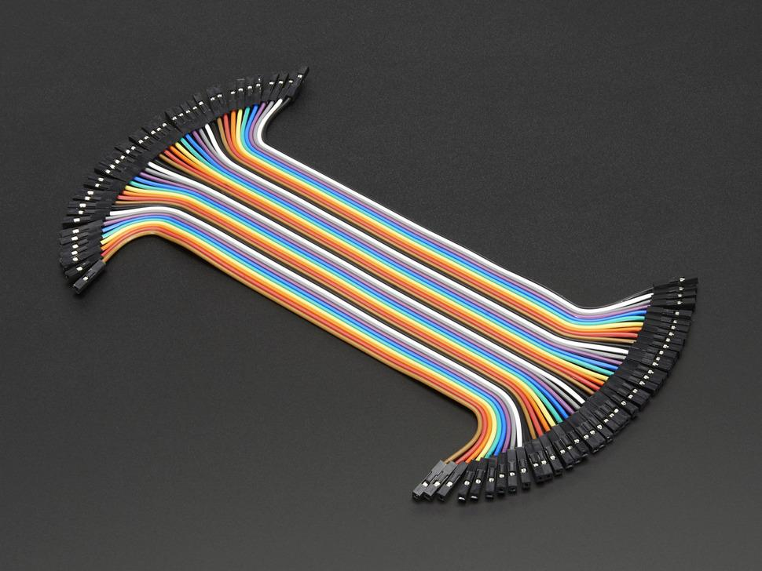

Parts list:

* 4 x 6” female-female jumper cable

Instructions:

* 1. Connect LED accordingly to silkscreen indication on PRi 2 LSD board
  2. silkscreen legend: Rx, Gx, Bx are red, green, and blue channels, accordingly, where x is the LED number; C is a common line (either common anode or common cathode)
  3. For adafruit LEDs are common anode type. The longest pin is common anode. Single pin on the side of common is red channel. The two other pins are Green and Blue channels, with the blue furthest from the common pin.
  4. Both types of LEDs are supported. Use shunt jumper to select either common anode (CA) or common cathode (CC) on 3-pin male header. Note, however, that all LEDs on the board must be of the same type.

## Part I - Connecting sensors

Parts list:

* 3 x 6” female-female jumper cable

Instructions:

* 1. Connect sensors according to silkscreen on RPi to LSD board.
  2. Ax indicates analog channel (x is between 0 and 3) for analog sensors, such as ultrasonic or infrared rangefinders. Note, ADC daughterboard must be installed in order to read sensor output.
  3. Dx indicates digital input or output, where x corresponds to Raspberry Pi 2 GPIO port.
  4. All sensors are supplied with 3.3 Volts and the ground on V and G lines, respectively. Read specific sensor datasheet before connecting.

**Your car is not ready to go!**

* You see those red plates? We want to put a big, beautiful, USB battery in there. But we need more space. These spacers and longer screws will increase the gap between the plates, allowing the battery to slide in.
* Follow the instructions provided in the chassis kit with these **two modifications**:
  + do NOT install the AA battery holder.
  + Use only four of the five provided standoffs; **omit the middle one** to allow the battery to slide in. The four standoffs used should form the corners of a rectangle.
  + Use the these four longer screws and spacers for each standoff.
  + (you will still use four of the eight small for each standoff)
  + [need to mention a way to keep the battery from sliding around.
* [Picture]
* wires on the inside

## Part J - putting everything together!

1. Stack the boards
   1. Screw the first eight standoffs into the Pi - provide hints on the location of standoffs and the suggested orientation of the boards w/r to the chassis
   2. connect the camera to the Pi [image showing the connector ?]
   3. Stack the DC/Stepper Motor HAT onto the Pi, aligning both sets of GPIO pins over each other and screw the standoffs to secure it. Try to not bend the camera connector too much during this step
   4. Stack the 16-channel PWM/Servo HAT onto the Pi, both sets of GPIO pins over each other and screw the standoffs to secure it
2. Slide the battery between the two chassis plates
3. Power the PWM/Servo HAT and Pi connecting them to the battery with the cables included in the duckie box
4. Power the DC/Stepper motor from the PWM/Servo HAT using the male-to-male cable in the duckie box, connect the positive
5. connect the Pi to the board
6. Finished!